**Mockito Hands-On Exercises**

**Exercise 1: Mocking and Stubbing**

Scenario: You need to test a service that depends on an external API.

Use Mockito to mock the external API and stub its methods.

Steps: 1. Create a mock object for the external API.

2. Stub the methods to return predefined values.

3. Write a test case that uses the mock object.

Solution Code:

import static org.mockito.Mockito.*;

import org.junit.jupiter.api.Test;

import org.mockito.Mockito;

public class MyServiceTest {

@Test public void testExternalApi() {

ExternalApi mockApi = Mockito.mock(ExternalApi.class); when(mockApi.getData()).thenReturn("Mock Data");

MyService service = new MyService(mockApi);

String result = service.fetchData();

assertEquals("Mock Data", result);

} }

**SOLUTION:**

**ExternalApi.java:**

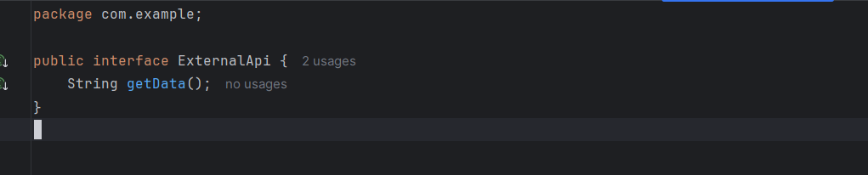

**MyService.java:**

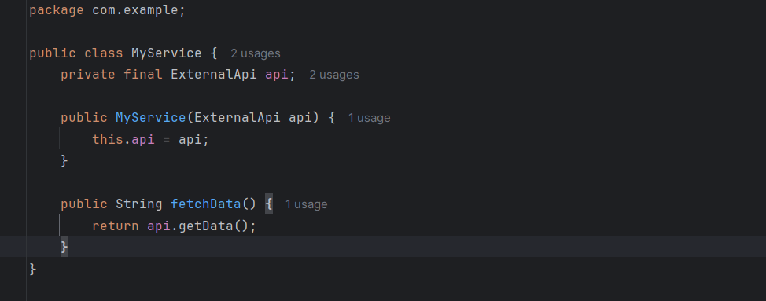

**MyServiceTest.java:**

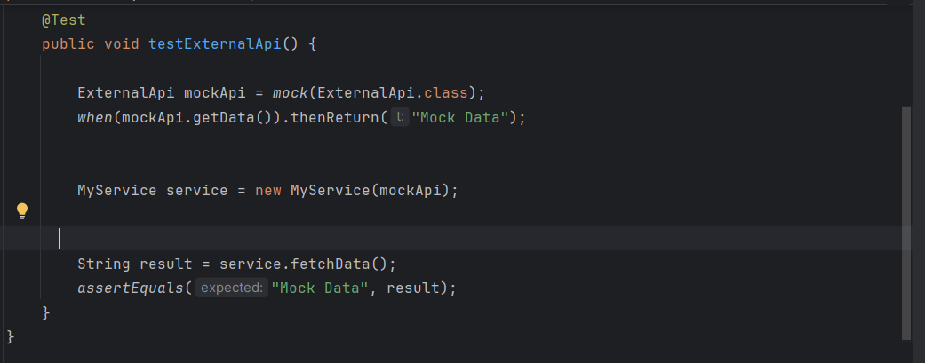

**OUTPUT:**

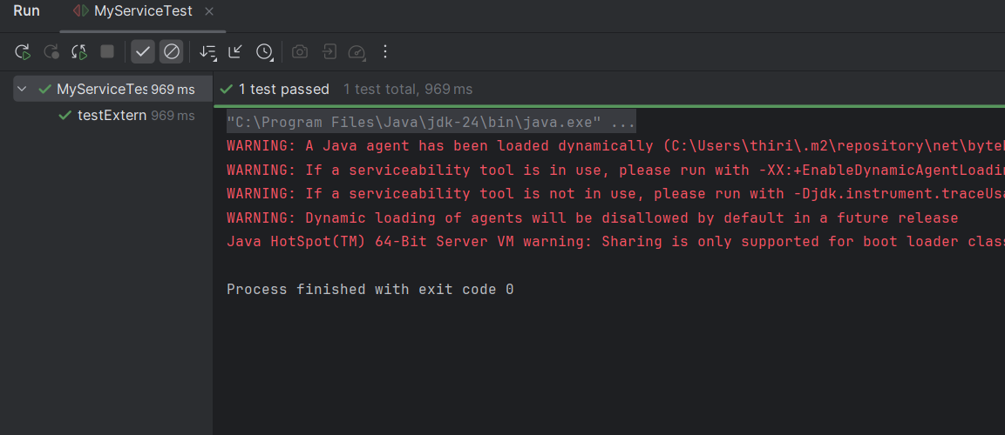

**Exercise 2: Verifying Interactions**

Scenario: You need to ensure that a method is called with specific arguments.

Steps: 1. Create a mock object.

2. Call the method with specific arguments.

3. Verify the interaction.

Solution Code:

import static org.mockito.Mockito.*;

import org.junit.jupiter.api.Test;

import org.mockito.Mockito;

public class MyServiceTest {

@Test public void testVerifyInteraction() {

ExternalApi mockApi = Mockito.mock(ExternalApi.class);

MyService service = new MyService(mockApi);

service.fetchData();

verify(mockApi).getData();

} }

**SOLUTION:**

**ExternalApi.java:**

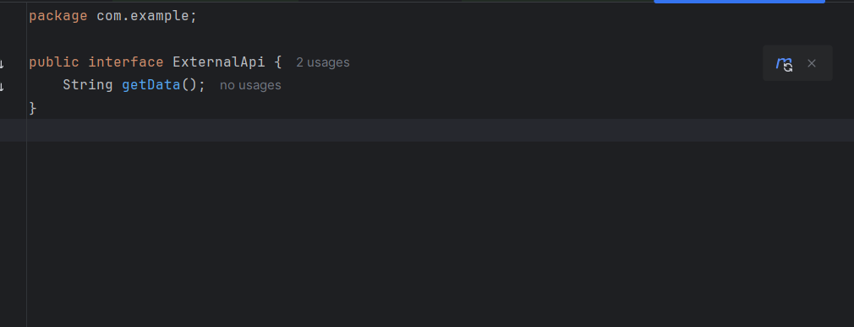

**MyService.java:**

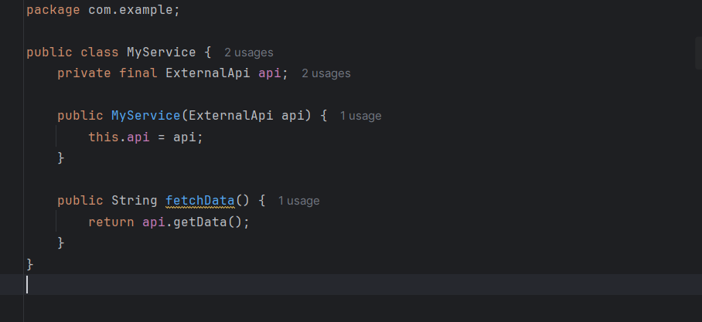

**MyServiceTest.java:**

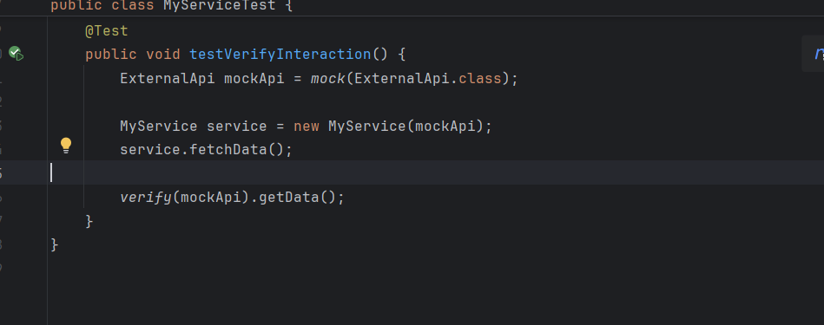

**OUTPUT:**

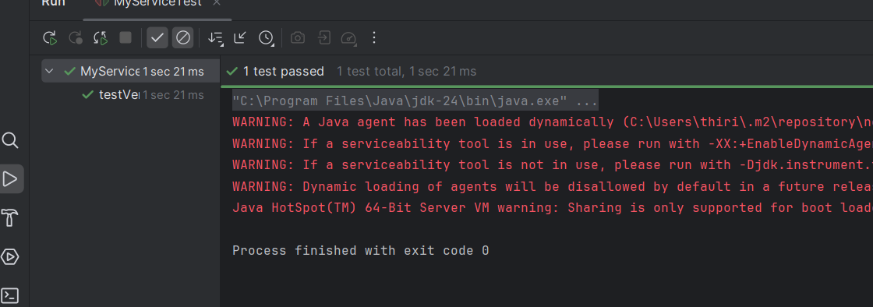

**Exercise 3: Argument Matching**

Scenario: You need to verify that a method is called with specific arguments.

Steps: 1. Create a mock object.

2. Call the method with specific arguments.

3. Use argument matchers to verify the interaction.

**SOLUTION:**

**EmailService.java:**

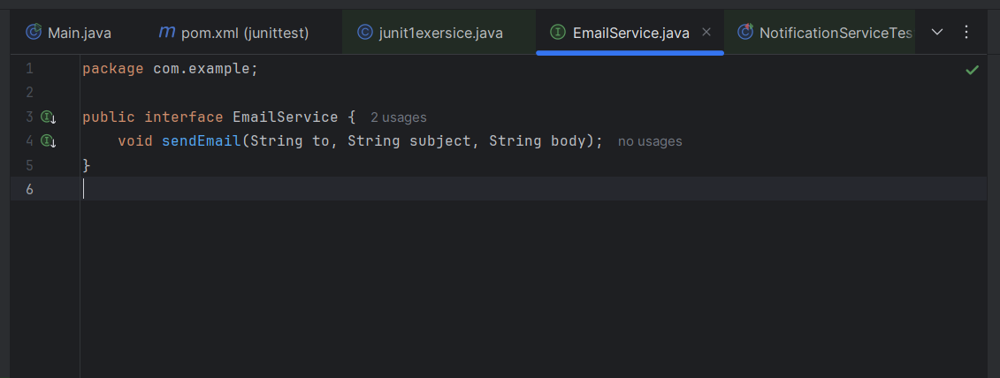

**NotificationService.java:**

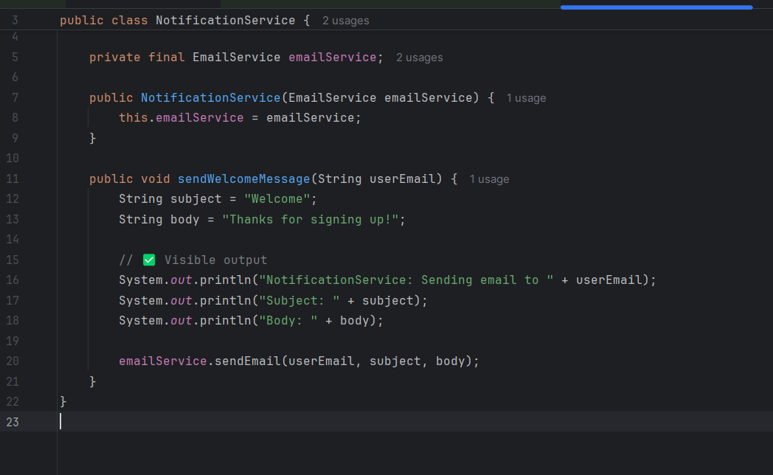

**AllTest.java:**

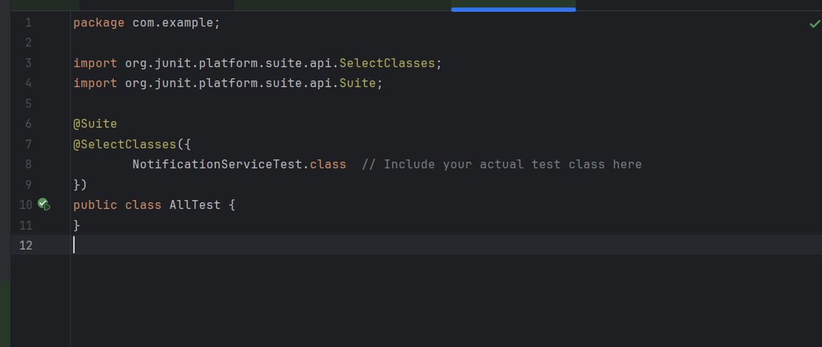

**NotificationServiceTest.java:**

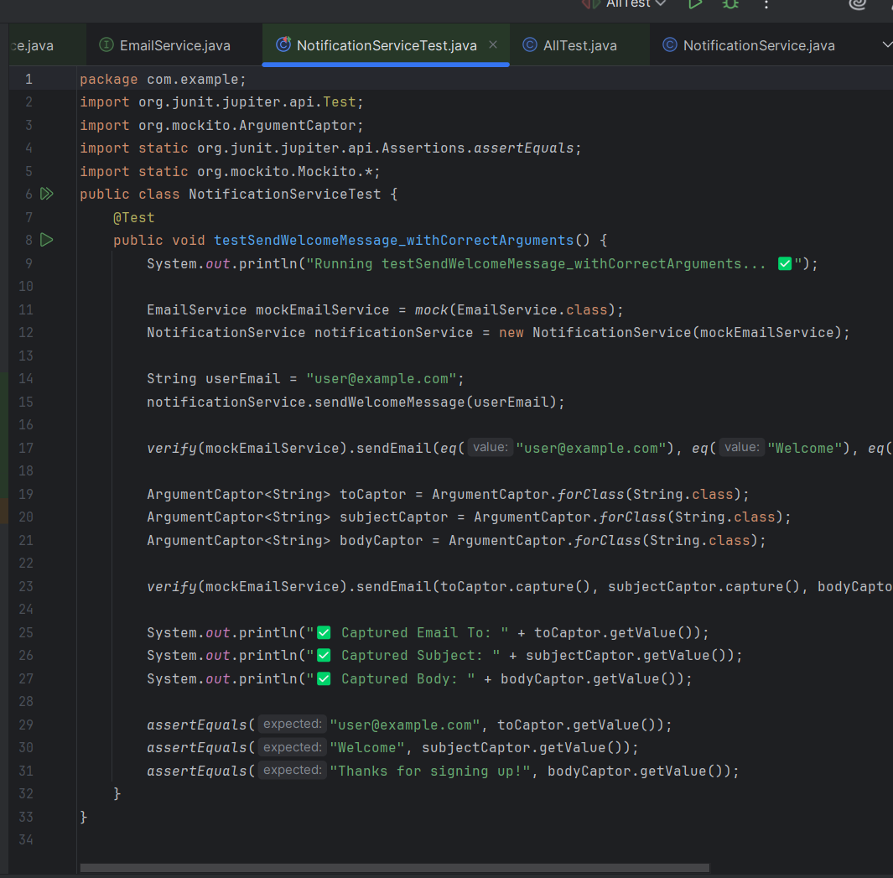

**OUTPUT:**

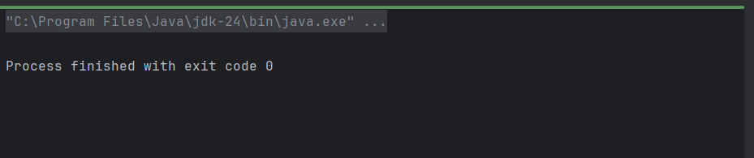

**Exercise 4: Handling Void Methods**

Scenario: You need to test a void method that performs some action.

Steps: 1. Create a mock object.

2. Stub the void method.

3. Verify the interaction.

**SOLUTION:**

**LoggerService.java:**

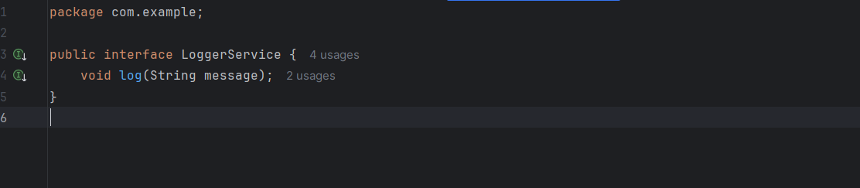

**UserService.java:** 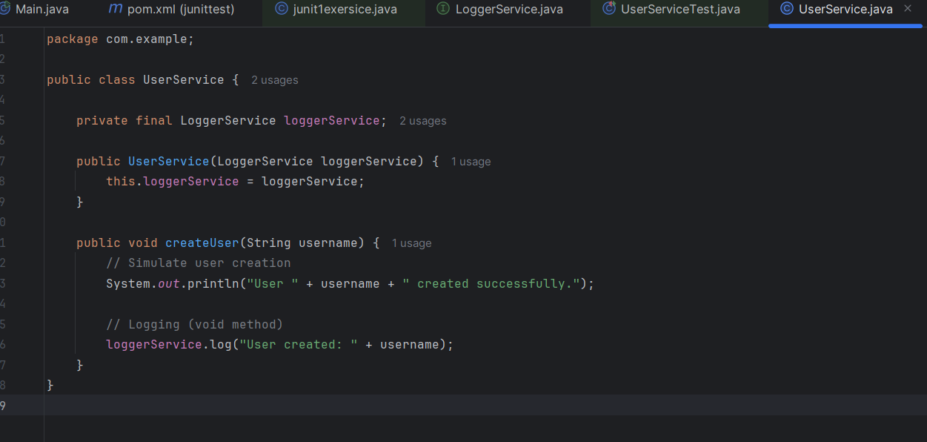

**UerServiceTest.java:**

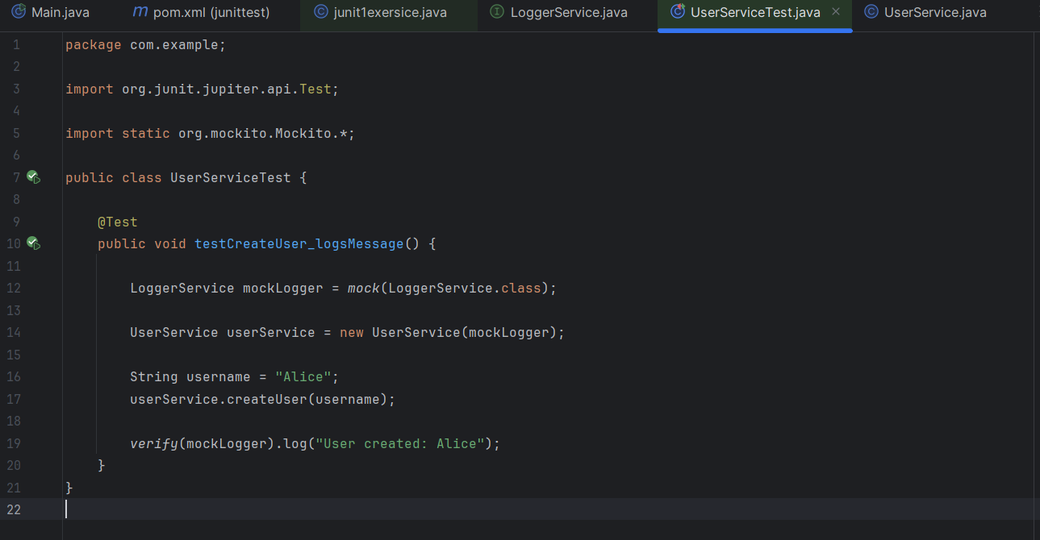

**SOLUTION:**

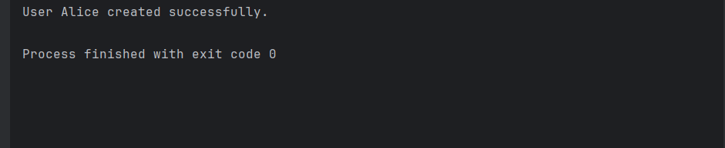

**Exercise 5: Mocking and Stubbing with Multiple Returns**

Scenario: You need to test a service that depends on an external API with multiple return values.

Steps: 1. Create a mock object for the external API.

2. Stub the methods to return different values on consecutive calls.

3. Write a test case that uses the mock object.

**SOLUTION:**

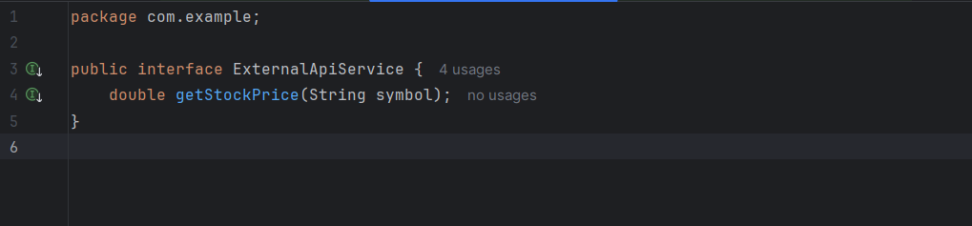

**StockMonitorService.java:**

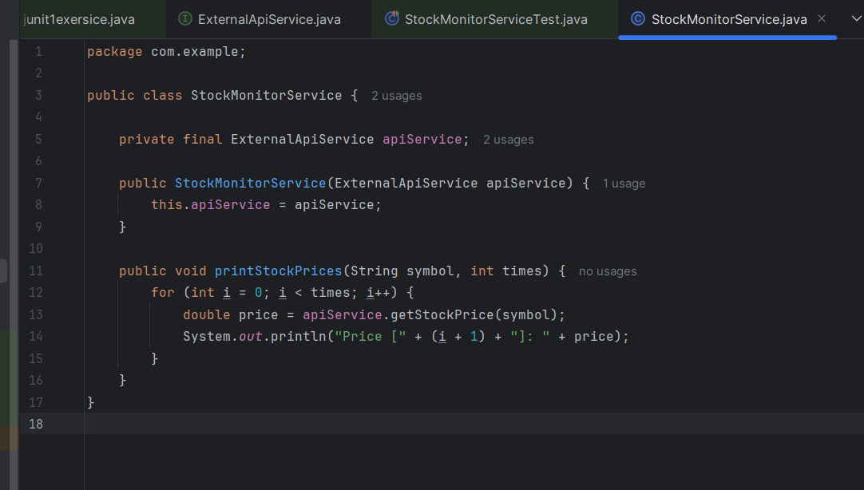

**StockMonitorServiceTest.java:**

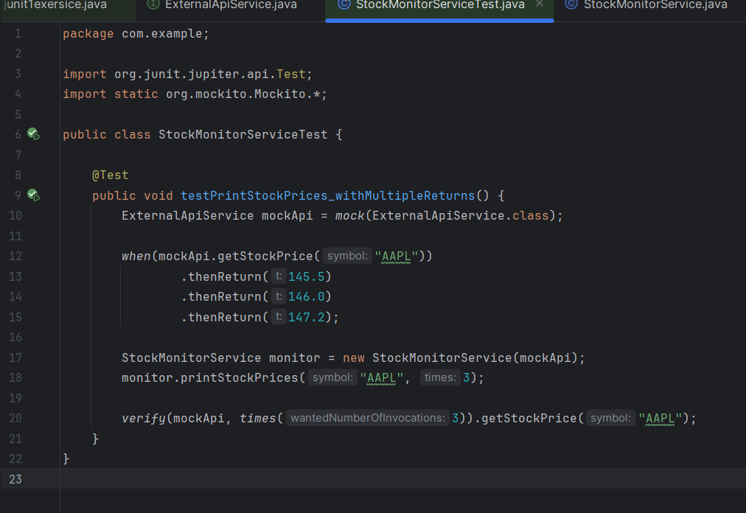

**OUTPUT:**

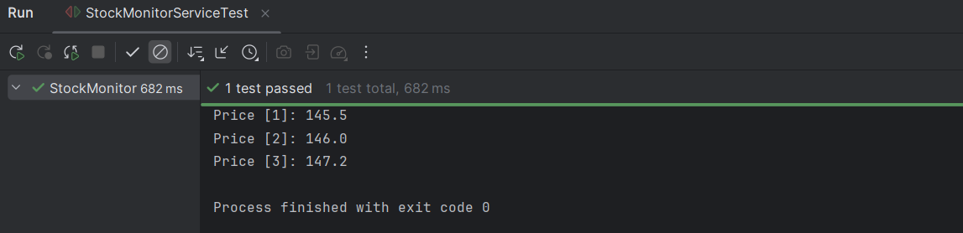

**Exercise 6: Verifying Interaction Order**

Scenario: You need to ensure that methods are called in a specific order.

Steps: 1. Create a mock object.

2. Call the methods in a specific order.

3. Verify the interaction order.

**SOLUTION:**

**NetworkClient.java:**

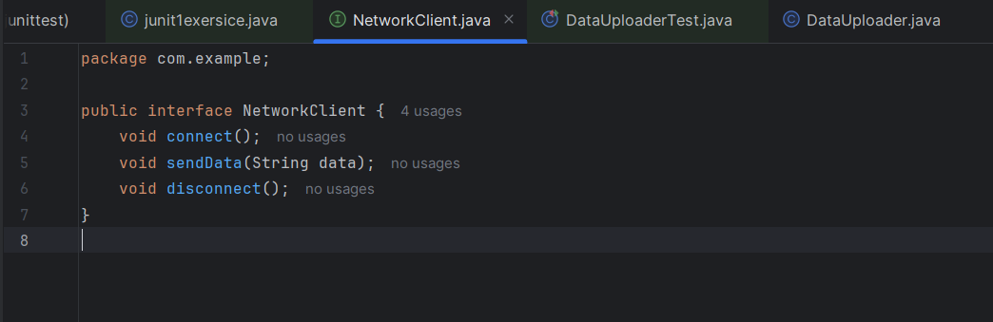

**DataUploader.java:**

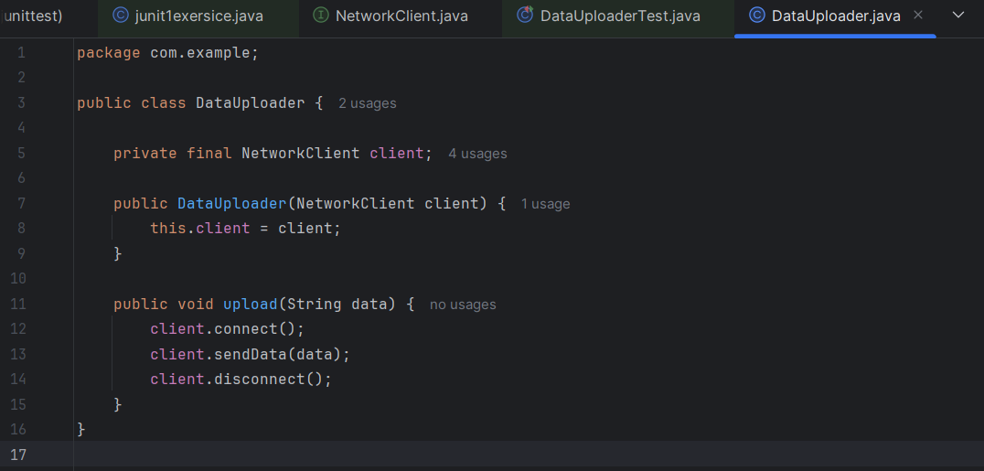

**DataUploaderTest.java:**

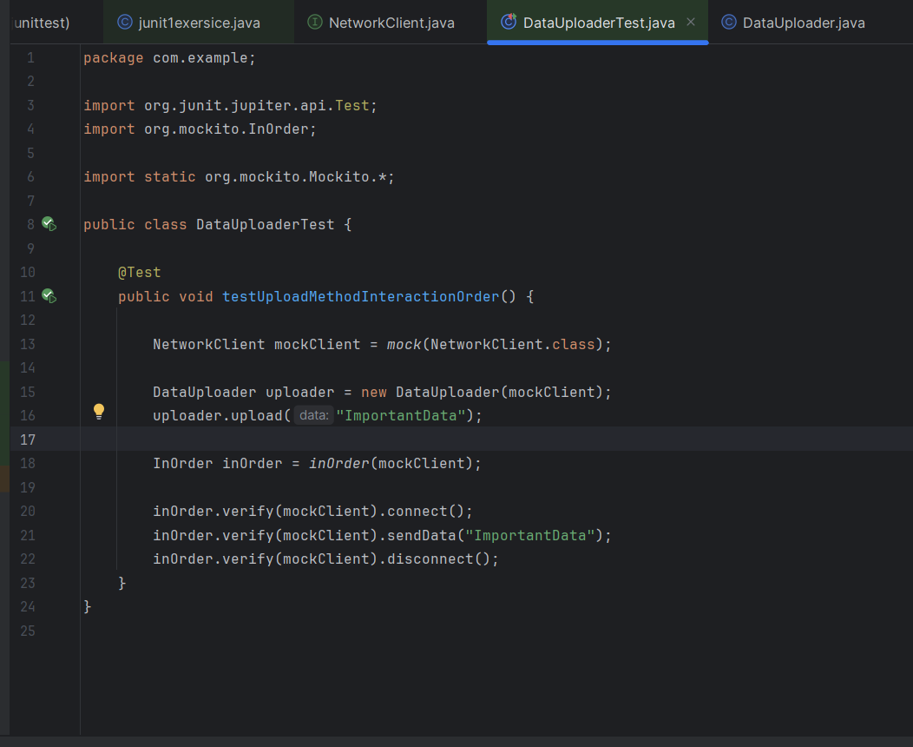

**OUTPUT:**

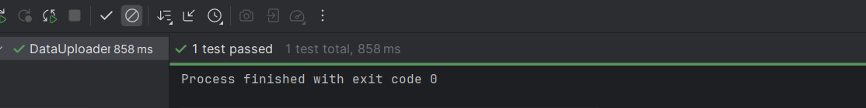

**Exercise 7: Handling Void Methods with Exceptions**

Scenario: You need to test a void method that throws an exception.

Steps: 1. Create a mock object.

2. Stub the void method to throw an exception.

3. Verify the interaction.

**SOLUTION:**

**FileService.java:**

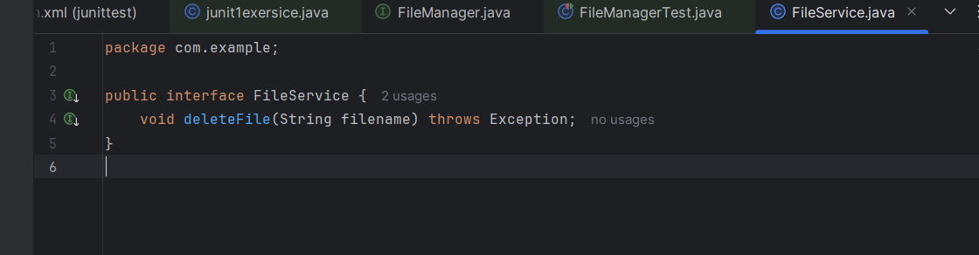

**FileManager.java:**

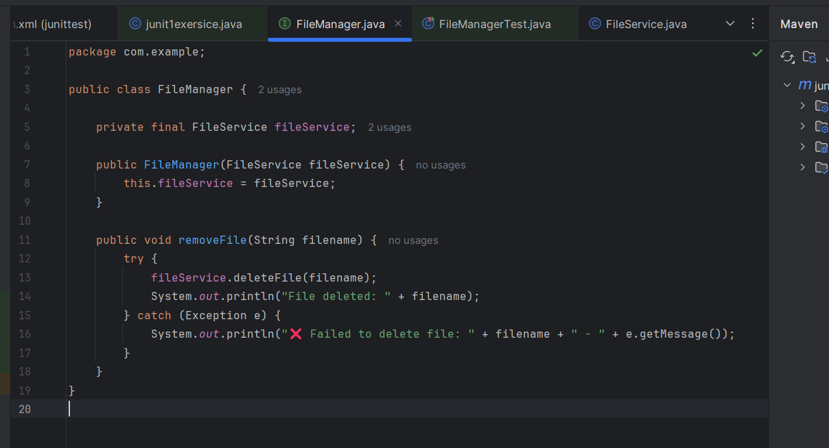

**FileManagerTest.java:**

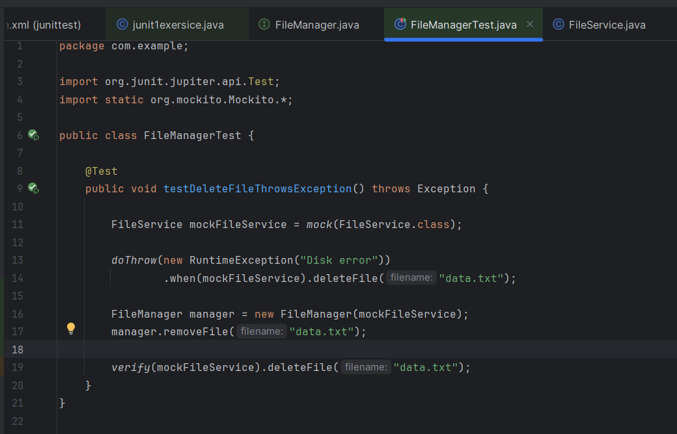

**OUTPUT:**

